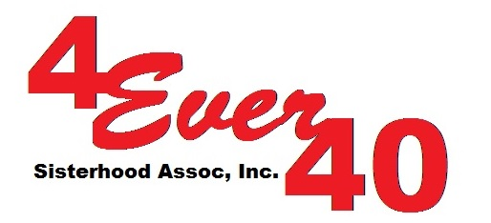

_________________________

_______________________
_______________________
_______________________

Dear

The 4Ever40 Sisterhood Association, Inc. has the highest degree of commitment and empathy in helping women and children through education to become self-sufficient. In support to achieving this mission, we have ongoing outreach projects in the Philippines like Akbay Pag-Asa Project in Caloocan City where 20 school children are given daily allowances of 50 pesos a day or 300 pesos a week. Another is the Basahang Pangkabuhayan Livelihood Program where 10 and 4 sewing machines were given to the single parents in Manila and Nueva Ecija respectively scholarship grants were also awarded to qualified women to attend Tech Voc School.

We need HELP to continue supporting and funding these projects. We want to reach out to people like you, people with a BIG HEARTS. We are inviting you to attend our annual fundraising event on September 16, 2017, the GALA-CTICA at Innisbrook Golf and SPA Resort in Palm Harbor, Florida.

As a valuable and prominent in the community, we would like to solicit donation or sponsorship for this event. (See attached Sponsorship Opportunities)

4Ever40 receives no United Way, state, local and federal funding. Thus, we rely on volunteers for all donations. Those served by 4Ever40 gets $500 for their education. So, far our organization sent almost 100 women and children in the school here in the USA and in the Philippines since 2013.

Let us all unite and be a part in making a difference in the lives of the needy and under privileged.

Please fill out the enclosed sponsorship form and send it to us at:

4Ever40 Sisterhood Association, Inc.
13215 Washington Ave.
Largo, FL 33773

Thank you for caring!

Rose E. DeMille
Founder/President

