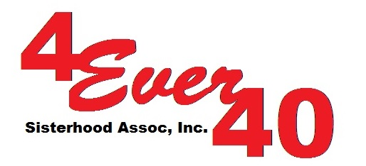

______________________
Date

______________________
______________________
______________________

Dear Mr. & Mrs. _____________________,,

The 4Ever40 has the highest degree of commitment and empathy in helping women and children through education to become self-sufficient. In support to achieving this mission, we have ongoing outreach projects in the Philippines like Akbay Pag-Asa Project in Caloocan City where 20 school children are given daily allowances of 50 pesos a day or 300 pesos a week. Another is the Basahang Pangkabuhayan Livelihood Program where 10 and 4 sewing machines were given to the single parents in Manila and Nueva Ecija respectively scholarship grants were also awarded to qualified women to attend Tech Voc School.

We need HELP to continue supporting and funding these projects. We want to reach out to people like you, people with a BIG HEARTS. We are inviting you to support and participate in our fundraising campaign the “King & Queen of the Galaxy” contest. This will be held on September 16, 2017 during the GALA-CTICA at the Innisbrook Golf and SPA Resort in Palm Harbor, Florida.

As a valuable and prominent couple in the community, we believe that you can influence family and friends to support our mission by selling tickets or sponsorship to this event. This is a FUN and friendly competition for the ‘POWER COUPLE”. This will give them also a chance to get involved and be an inspiration to our children.

Let us all unite and be a part in making a difference in the lives of the needy and underprivileged.

To register, please fill out the enclosed application form and send it to us at:

4Ever40 Sisterhood Association, Inc.
13215 Washington Ave.
Largo, FL 33773

Once we received your application, you will be given a fundraising packet to start the race.

Again, thank you so much and may the good Lord bless us all in this endeavor.

Rose E. DeMille
Founder/President
4Ever40 Sisterhood Association, Inc.

