SPONSOR AD FORM

$100 Sponsorship $50 Sponsorship

Name______________________________________________

Company ___________________________________________

Type of Business_______________ Tel No.________________

Advertisement : You business card or electronic layout of your ad to forever40sisterhood@yahoo.com

Examples:

$100 Business Card Ad

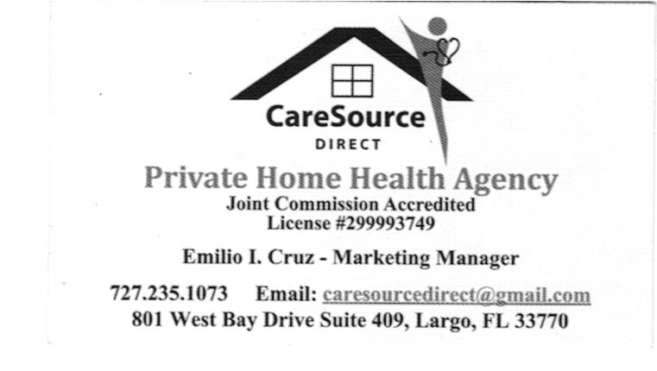

$50 Greetings Ad

“Happy New Year to All”
Dr. & Mrs. Mel & Thelma Allego

SPONSOR AD FORM
Use this form

$100 Sponsorship $50 Sponsorship

Name______________________________________________

Company ___________________________________________

Type of Business_______________ Tel No.________________

Advertisement : You business card or electronic layout of your ad to forever40sisterhood@yahoo.com

Confirmed _______________________ Date__________________
Advertiser Name & Signature

Solicited by ______________________

