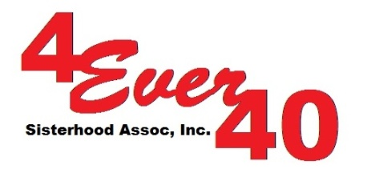

Dear Scholarship Applicants,

Thank you for your interest in the 4Ever40 Sisterhood Association, Inc. Scholarship Program.

We are very excited to help you along your path to empowerment through education, ultimately leading to your self-sufficiency, financial ability and independence.

Enclosed with this letter is the application packet that includes:

- Scholarship application form
- Scholarship program guidelines
- Referral letter form (2)

For any assistance or question in completing these forms, please call:
Rose DeMille at (727)481-8733 or Lisa Nettle at (727)709-5873. If in case we are unable to answer the phone, please leave your name, phone number and the reason why you called and we will get back to you as soon as we can.

When all the forms are completed and signed, please return/mail to:

4Ever40 Sisterhood Association, Inc.
8831 Suite 6, 49th Street N.
Pinellas Park, FL 33782

Goodluck and wishing you the best!

Rose E. DeMille
Founder/President

